 The UK national learned society and professional
body promoting pure and applied cybernetics

http://www.cybsoc.org/

The Cybernetics Society holds scientific meetings, conferences, and social events, and engages in other activities to encourage public understanding of science and to extend and disseminate knowledge of cybernetics and its associated disciplines. In particular, it aims to support the Continuing Professional Development of its members.
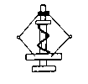The Society was founded at King's College London in 1968. Its Annual Conferences, and monthly scientific meetings for members within reach of London, have usually been held at King's College ever since.
CybCon2004 presented with Metaphorum
Cybernetics and Public Administration
Friday 3rd September 2:00pm St James Park else 3.00pm Parliament Room, The Clarence 53 Whitehall London SW1A 2HP

14.00 Welcome and Discussion of posters, meet on the deck chairs – parallel dynamically
clustered sessions
15.00 In the Parliament Room at The Clarence (drinks and food available).

18.30 "Later in the Bar" & Dinner (optional)

Saturday 4th September 10:00am Room S221, St Clements Building, London School of Economics, Houghton Street, London WC2A 2AE
10.00 Prof Alfredo Moscardini FCybS of Metaphorum "Future collaborations"

10.45 Dr Allenna Leonard FCybS, Dr Marcela Villarreal, Dr Angela Espinosa FCybS, John Clarke, "Measuring welfare and development using Beer and Max-Neef models and tools. Possibilities for systemic development on the AIDS Program from FAO”
John Clarke, UN World Health Organisation, "Accountability of the UN System in the context of HIV/AIDS in Southern Africa: Cybernetic insights for enhancing the response-ability of UN Country Teams."
Dr Angela Espinosa FCybS, University of Hull: "Applied Cybernetics in development of socio economic programs. Learnings on measuring welfare and socio economic development"
Dr Marcela Villarreal, UN Food and Agricultural Organisation “FAO support on governmental program for AIDS: Current philosophy, and approach and important challenges faced at the moment”
Lunch
14.00 Dr Steve Wright Omega Foundation "A Systems Description of the Northern Ireland Conflict"
14.45 Presentation and Plenary Discussion on
“Identity and Structure”
Dr Paul Stokes FCybS Trinity College Dublin and Luc Hoebeke
17.45 Close: Prof Alfredo Moscardini FCybS University of Sunderland for Metaphorum
To register your interest or to book your place e-mail: nick_green@cybsoc.org
Further enquiries 020 7916 0285
Approved Students: Free Friday £5.00 Saturday £15.00 Non- Members and Guests £20.00
Payment: at venue or send cheques etc payable to: Metaphorum Society
c/o Prof Alfredo Moscardini, University of Sunderland,
Room 215, SCET, Sunderland SR6 0DD, United Kingdom
Invoices Leonie Solomons at Metaphorum: Leonie.Solomons@sunderland.ac.uk
Participants may care to meet for a picnic on the deckchairs in St James Park on Friday at one o'clock and at Caffe Amice No1 Aldwych on Satuurday at nine o'clock for breakfast. Dinner will be at Salieri cost starts at £12.50. Participants buy their own drinks and food but venues selected to keep costs minimal.
Joining Instructions, Accomodation and Maps of locations at our websites above.

Conference Announcement
CybCon 2003
Recent Topics in Cybernetics
Room S421, 4th Floor, St Clements Building
London School of Economics, Houghton Street, London WC2A 2AE
From 10:00 to 17:00 on Saturday 13th September 2003
Mr Karl-Gustav Hansson Statistics Sweden
"Improved National Accounts"
Continuous updating of economic data for consolidating monthly, quarterly and yearly national accounts.
Dr John Chandler FCybS
"Iraq"
Mr N Green FCybS Cybernetics Associates
Interaction of Actors Theory and the Viable System Model
The isotopy of the orthogonal Borromean link and the Icosahedral Tensegrity (subject to revision)
Dr David Dewhurst
"Games Theory, Monopoly and the vivarium: systematic shortfalls of simulation"
Prof. Petros A.M. Gelepithis Director, Cognitive Science Laboratory, Kingston University, England.
email: Petros@kingston.ac.uk
"Towards an Axiomatic Theory of Mind"
We aim to illustrate an axiomatic approach towards the development of a Theory of Mind (ToM). We specify necessary and sufficient conditions for intelligence as part of a ToM and a suggestion for the nature of consciousness. We conclude with a brief summary of further work.
Dr Ranulph Glanville FCybS School of Architecture + Design RMIT University Melbourne
"Another Topic"
Dr Bernard Scott FCybS Cranfield University Royal Military College of Science
"Icosahedral Tensegrity"
Mr Tony Wilkes MCybS Organum Ltd
"Moores Law: The Beginning of the End"

Conference Dinner £10
Approved Students Free Members and Guests £20.00
Papers invited for our monthly Evening Meetings
Further Announcements at www.cybsoc.org

The Cybernetics Society is one of the 35 societies or institutions affiliated to the World Organisation of Systems and Cybernetics (WOSC). For more information visit its website www.cybsoc.org/wosc
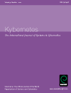The Society has a close relationship with Kybernetes - The International Journal of Systems and Cybernetics, which is the official journal of WOSC. Papers presented to our scientific meetings and conferences can be assessed by Kybernetes editors for publication in this prestigious peer-review journal. Both traditional paper format subscriptions and Personal Electronic Subscriptions are available. For more information visit its website www.emeraldinsight.com/kyb.htm
Origins of Cybernetics
Extracts from "An essay on the Origins of Cybernetics" by Dr D. J. Stewart, Vice-President of The Cybernetics Society. The full text can be found at:
www.hfr.org.uk/cybernetics-pages/origins.htm
The first meeting of the new group was held in March 1946, with the title "Feedback Mechanisms and Circular Causal Systems in Biological and Social Systems". Two more meetings were held that year: in September, one on "Teleological Mechanisms in Society", and in October, another on "Teleological Mechanisms and Circular Causal Systems", at which Rosenblueth and Wiener described experiments which they had been doing on clonus in cat leg muscle.
The New York Academy of Sciences was stimulated to ask the same group to hold a symposium on "Teleological Mechanisms" which was subsequently published (Frank et al., 1948).
The third Josiah Macy Conference was held in 1947, again on teleological mechanisms, and the fourth and fifth, which was chiefly concerned with the structure of language, were in 1948.
By the summer of 1947, the science of control and communication had developed to such an extent that it was beginning to be inconvenient not to have a name for it, and so the term 'cybernetics' was coined. From Wiener's Cybernetics (1948): "We have decided to call the entire field of control and communication theory, whether in the machine or in the animal, by the same 'Cybernetics', which we form from the Greek kubernetes or 'steersman'".
About the Society
The Society objects are pursuant to the special authority of 10 June 1976 given under section 7(1)(f) of the Friendly Societies Act 1974. This is an authorisation given by H.M. Treasury. The Society is a Specially Authorised Society and its Register No. is 195 S.A.

The Society objects are pursuant to the special authority of 10 June 1976 given under section 7(1)(f) of the Friendly Societies Act 1974. This is an authorisation given by H.M. Treasury. The Society is a Specially Authorised Society and its Register No. is 195 S.A.

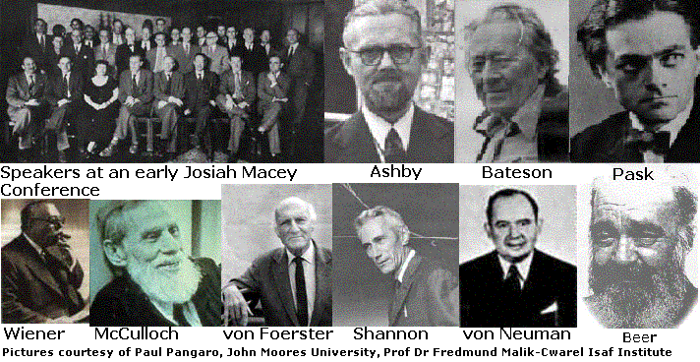Some Founders of Cybernetics
Grades of membership

Member The Council may at its absolute discretion elect any person who holds a suitable degree to be a Member of the Society. Members (except those who are three months or more in arrears with their subscriptions) will be entitled to use the initials 'M.Cyb.S.' after their names.
The Society's President, Professor Martin Smith recently attended the launch of three state-of-the-art presentation robots with the Minister for the Environment, the Rt. Hon. Michael Meacher, at the House of Commons.
The robots were specially designed and built by the President and one of his former students, David Buckley, for the environmental education charity Waste Watch. Each robot, which contains four microcontrollers and an MP3 player, will visit up to ten schools per week promoting the message of waste minimisation. The charity found that children pay more attention to the message from the robots than the message presented by the robot's operator. Further details can be found on www.robot.org.uk
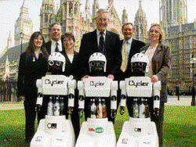
The President (2nd from the left) and Michael Meacher (4th from the left) with the Waste Watch team.

The Society's President, Professor Martin Smith recently attended the launch of three state-of-the-art presentation robots with the Minister for the Environment, the Rt. Hon. Michael Meacher, at the House of Commons.
The robots were specially designed and built by the President and one of his former students, David Buckley, for the environmental education charity Waste Watch. Each robot, which contains four microcontrollers and an MP3 player, will visit up to ten schools per week promoting the message of waste minimisation. The charity found that children pay more attention to the message from the robots than the message presented by the robot's operator. Further details can be found on www.robot.org.uk
The President (2nd from the left) and Michael Meacher (4th from the left) with the Waste Watch team.

The current annual subscription for Members is £20.
Fellow The Council may at its absolute discretion elect to the membership grade of Fellow of the Society any member who holds a suitable higher degree, awarded in whole or in part for a contribution to the field of cybernetics, or who has published suitable contributions to the field of cybernetics of an academic standard equivalent thereto. Fellows (except those who are three months or more in arrears with their subscriptions) will be entitled to use the initials 'F.Cyb.S.' after their names.
The current annual subscription for Fellows is £20.
Associate The Council may at its absolute discretion elect such persons as it thinks fit to be Associates of the Society. The Council may at any time terminate the rights, privileges and benefits of any Associate. All provisions with regard to Associates shall save as provided by these Rules be prescribed by the Bye-laws.
The current annual subscription for Associates is £20. However, for bona fide students of courses approved for the purpose by the Council it is reduced to £10.
Honorary Fellow The Council may recommend, for election by a General Meeting as Honorary Fellows of the Society, persons of distinction who have contributed to the advancement of cybernetics. Honorary Fellows will be entitled to all the rights, privileges and benefits of membership but shall not be required to pay any subscription.
Honorary Fellows:  Professor Sir Eric Ash FRS  Professor H. B. Barlow FRS  Professor Stafford Beer [died 23 August 2002]  Sir James Black FRS, Nobel Laureate  Sir Walter Bodmer FRS  Professor Sir John Eccles FRS, Nobel Laureate  Professor P. B. Fellgett FRS  Professor B. D. Josephson FRS, Nobel Laureate  Professor J. E. Lovelock FRS | Officers of the Society:  President  Professor Martin Smith  Vice-President  Dr D.J. Stewart  Secretary  Dr D.W. Dewhurst  Treasurer  Dr W.J. Chandler | Trustees:  Dr A.M. Andrew  Professor Martin Smith  Further Members of Council:  Dr P.A.M. Gelepithis  Nick Green  Dr W.J. Pratt  Dr B.C.E. Scott  Consultants to the Council:  Dr Brian Warburton
How to apply for membership of the Society: To apply to become a member of the Society write a brief letter of application to the Secretary:
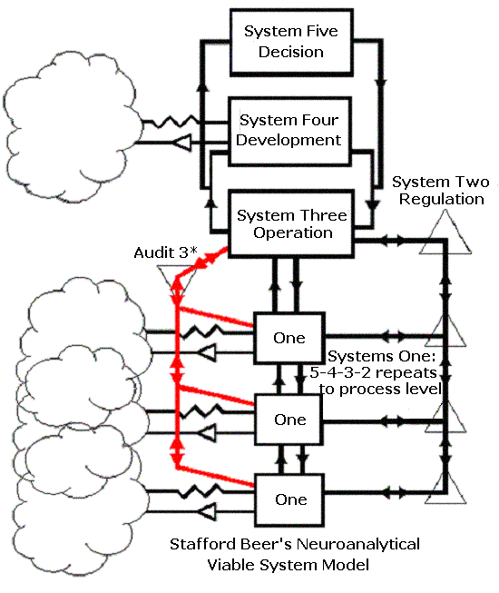
Dr D.W. Dewhurst, email: david@dewhurst.net
17 Challis Road,
Brentford, Middlesex TW8 9PP

Secretary
Dr D.W. Dewhurst,
17 Challis Road,
Brentford, Middlesex TW8 9PP
E-mail: david@dewhurst.net
Include in your letter details of any relevant research projects, employment, publications or other contributions, and any other associations you have had with cybernetics or its applications. If you already possess a recent CV (resume), a copy of that may be the easiest way of giving this information.
A Word document of the Standing Order Mandate form is provided on this website. Ideally, just print it out, fill it in and include it with your letter.
However, if you would prefer not to make out a Mandate at this stage, you can leave the lower part of the form blank; but please do fill in the top part, giving your contact details. If you do not fill in the Standing Order Mandate, you should instead include a cheque for £20.00 made out to The Cybernetics Society, London. This is on account of your subscription up to 1st January 2003. From then on, your subscription will be £20.00 annually, payable on each 1st January, at whatever grade of membership you are admitted. If elected, you will be admitted to the grade of membership that the Council think appropriate, based on the information that you have provided.
Ross Ashby anticipated the development of Cybernetics with his paper "Adaptiveness and Equilibrium" in J. Ment. Sci. 1940. In 1956 he generalised Shannon's treatment of digital communication into a Central Theorem for Cybernetics
Law of Requisite Variety
"Variety absorbs Variety"
where Variety is the number of states of a system. In 1970 structure was added when, with Conant, he showed an isomorphic model was necessary for good regulation. Prior to that, also in 1956, Kolomogorov applied Shannon's methods to the analogue case by identifying number of measurements with "bounded accuracy" thus permitting wider application of Ashby's fundamental Law.

Dr W. Ross Ashby anticipated the development of Cybernetics with his paper "Adaptiveness and Equilibrium" in J. Ment. Sci. 1940. In 1956 he generalised Shannon's treatment of digital communication into a Central Theorem for Cybernetics

Law of Requisite Variety
"Variety absorbs Variety"

where Variety is the number of states of a system. In 1970 structure was added when, with Conant, he showed an isomorphic model was necessary for good regulation. Prior to that, also in 1956, Kolomogorov applied Shannon's methods to the analogue case by identifying number of measurements with "bounded accuracy" thus permitting wider application of Ashby's fundamental Law.
Dr Harold Black coined the term negative feedback to describe his phase shifting invention, conceived on Aug. 2 1927 whilst on the Hoboken ferry on his way to work, which reduced noise in Bell's long distance amplifiers.
Correcting errors due to noise, optimally, was the motivation for the work on Information Theory at Bell Labs by Nyquist, Hartley and, later, in 1948 Shannon.
In general, where p_{i} is the probability of a symbol, the average Information content in bits of a message of n different symbols is identical to the thermodynamic negentropy and we may write: $H_{n}=−\sum_{i=1}^{i=n}{p_{i}{\text{log}}_{2}p_{i}}$
Shannon's famous Tenth Theorem defined Bandwidth capacity, C, as limited by noise entropy thus $C=H_{n}−H_{\text{noise}}$. This laid a formal physical basis for the logic of automatic error correction and detection we routinely use today in the Internet TCP/IP protocols and all digital data transmission.

Evening Programme 2003/2004
at King's College Franklin/Wilkins Building
Stamford Street London SE1 9NN:
Events start at 6.30 p.m. and are generally held on the last Monday of each month in Room 4.63. Approved students are welcome and Guests should contact a Member of Council. Discussions sometimes continue over Dinner.
24 Nov | Pask IA Axioms can produce a Viable System | Mr Nick Green FCybs
26 Jan 2004 | Discussion Meeting: Members' Short Papers | Drinks afterwards
23 February | Motivated Irrationality: Dramatec in NHS | Prof. Keith Cash
29 March | Further Loose Ends in Cybernetic Thinking | Dr Alex Andrew FCybS
 THE CYBERNETICS SOCIETY
In June 1976 in an Interview with his wife, another co-founder of cybernetics, Margaret Mead, and Stewart Brand, Editor of CoEvolutionary Quarterly, Gregory Bateson contrasted First and Second Order Cybernetics with this diagram. It emphasises the requirement for a possibly constructivist (private, finite, serial model- making) observer in Second Order case.
Last year the society invited leading practitioners to discuss their work in relation to this model and this became the subject of last year's Conference.
Gordon Pask PhD, ScD, DSc. developed Conversation Theory (CT), a learning theory, in 1975 and the general theory of self-organisation, Interactions of Actors (IA), in 1992. The axioms apply to both theories.
Axioms for Interactions of Actors (1994)
Context and Perspective: The local neighbourhood and the position of the participant observer or actor in it.
Respectability and Responsibility: Observability in both the classical and quantum sense. Excitation of a respectable actor is required if it is cold to make it responsible.
Amity The availability of actors for interaction.
Agreement and Agreement-to-disagree: Produced when a concept is shared. In Agreement a stress is copied and repulsion produced. In Agreement-to-disagree a stress is not copied and an attraction is produced.
Purpose and Unity that is not uniformity: Defines the difference that is feedback. Unity that is not uniformity defines a similarity defining a group. Purpose retains applicability in referring to convergent behavioural outcomes of the potentially equifinal kind. The goal of goals is to stay warm.
Faith: A property of a concept or assertion that persists until a contradictory counter example is found; the duration of an observation or experiment.
Beginnings and Ends (CT) and Eternally Interacting (IA), Kinematic(CT) and Kinetic(IA): Properties that distinguish CT and IA.
Similarity and Difference: Distinguishes concepts that attract and repel.
Adaptation, Evolution and Generation: The consequence of change and growth.
Conservation of Meaningful Information Transfer both Permissive (Ap) and Imperative Application (Im): The equilibrium of imperative forces produces permissive application of concepts.
Informational Openness and Organisational Closure: The conventional requirements of second order cybernetic systems. All such processes are concepts to Pask- products of self-organisation in all media from Stars to Brains.
Void and Not-Void: The structure of the space supporting Actors which support M-Individuals in which P-Individuals interpret their concepts.
Pask's Last Theorem
Like concepts repel unlike concepts attract
CybCon2002: Developing Second Order Cybernetics
Gordon Pask developed Conversation Theory (CT), a learning theory, in 1975 and the general theory of self-organisation, Interactions of Actors (IA), in 1992. The axioms apply to both theories.
Axioms for Interactions of Actors (1994)
Context and Perspective: The local neighbourhood and the position of the participant observer or actor in it.
Respectability and Responsibility: Observability in both the classical and quantum sense. Excitation of a respectable actor is required if it is cold to make it responsible.
Amity The availability of actors for interaction.
Agreement and Agreement-to-disagree: Produced when a concept is shared. In Agreement a stress is copied and repulsion produced. In Agreement-to-disagree a stress is not copied and an attraction is produced.
Purpose and Unity that is not uniformity: Defines the difference that is feedback. Unity that is not uniformity defines a similarity defining a group. Purpose retains applicability in referring to convergent behavioural outcomes of the potentially equifinal kind. The goal of goals is to stay warm.
Faith: A property of a concept or assertion that persists until a contradictory counter example is found; the duration of an observation or experiment.
Beginnings and Ends (CT) and Eternally Interacting (IA), Kinematic(CT) and Kinetic(IA): Properties that distinguish CT and IA.
Similarity and Difference: Distinguishes concepts that attract and repel.
Adaptation, Evolution and Generation :The consequence of change and growth.
Conservation of Meaningful Information Transfer both Permissive (Ap) and Imperative Application (Im):The equilibrium of imperative forces produces permissive application of concepts.
Informational Openness and Organisational Closure: The conventional requirements of second order cybernetic systems. All such processes are concepts to Pask. and the outcome of self-organisation in all media from Stars to Brains
Void and Not-Void: The structure of the space supporting Actors which support M-Individuals in which P-Individuals interpret their concepts.
Pask's Last Theorem
Like concepts repel unlike concepts attract
Dr Alex Andrew FCybS
Reminiscences of McCulloch and Pitts and some others
Recollections of a fruitful and colourful period in the mid-nineteen-fifties. Most of the events to be recalled are prior to the emergence of second-order cybernetics, at least by that name, but early trends towards it will be mentioned.
Mr A Booth MCybS
Essential Structure in Physical Observation
At the heart of any process of observation there are certain basic things which must happen. A conference pre-print can be found at: www.abooth.co.uk/obs/observ.html
Mr N Green FCybS Real Time Study Group, Department of Computer Science, University of Wales, Cardiff
Axioms from Interaction of Actors Theory
While working with clients in the last years of his life Gordon Pask produced two axiomatic schemes. These axioms are discussed as characteristic of field concurrence and the second order cybernetic canon. www.cyberneticsassociates.co.uk
Professor Gerard de Zeeuw
Systems and Strawmen
Some historical material will be presented about the development of systems theory in a scientific context.
Dr Ranulph Glanville FCybS School of Architecture + Design RMIT University Melbourne
Thinking Second-Order Cybernetics
A review of the benefits and problems of applying second-order cybernetics.
Dr Bernard Scott FCybS Cranfield University Royal Military College of Science
Second-Order Cybernetics in historical context
An introductory talk on the historical developments that lead up to Heinz von Foerster's making an explicit distinction between first and second order cybernetics.
Panel Discussion
Convened by Dr Glanville and Dr Scott, and featuring all presenters with the aim of clarifying understandings of what second-order cybernetics is, what it has to offer and what may be looked for by way of future developments.
Members £15.00; Non-Members £20.00;Approved Students Free
Any queries? Call Nick Green on +44 (0)20 7916 0285 or nick_green@blueyonder.co.uk
Any queries? Call Nick Green on +44 (0)20 7916 0285 or nick_green@blueyonder.co.uk

